*Check on Stride Integration*

For cyclic, motion if all the motion variables return to the same values at the end of a cycle, then reconstructing the displacement from an accelerometer time history should not depend on the integration start time.

To confirm this method the variation of longitudinal, lateral and vertical accelerations have been represented by a combination of sine waves or sine squared waves which can be sampled from any start position defined by the selected phase angle eps. [ Programmed in Python Program

STRIDEAVIMUB2mGPSsine

With no phase lag mset = 0

The reconstruction of x,y,z is carried out in Python program

SreconITSBqhood2

mset = 0 ---- zero phase lag

mset = 600 +ve phase lag

SreconITSBqhood2

Analysis on Sunday 29th AUGUST showed that displacement could be reproduced from the integration of a simple sine wave irrespective of the time of the integration. Provided that the initial velocity was correctly determined. This was confirmed in an XL program and also in the PYTHON program SreconITSBqhood2

Analysis was carried out on Tuesday 1st September with a simple sine function for lateral acceleration and composite sine functions for forward and vertical acceleration.

The vertical sine function contained a (sine)sq function.

The displacements were reconstructed with starting point zero samples and starting point 600 samples.

The comparison of reconstructions is shown below

Start index 0 600

zvs.x

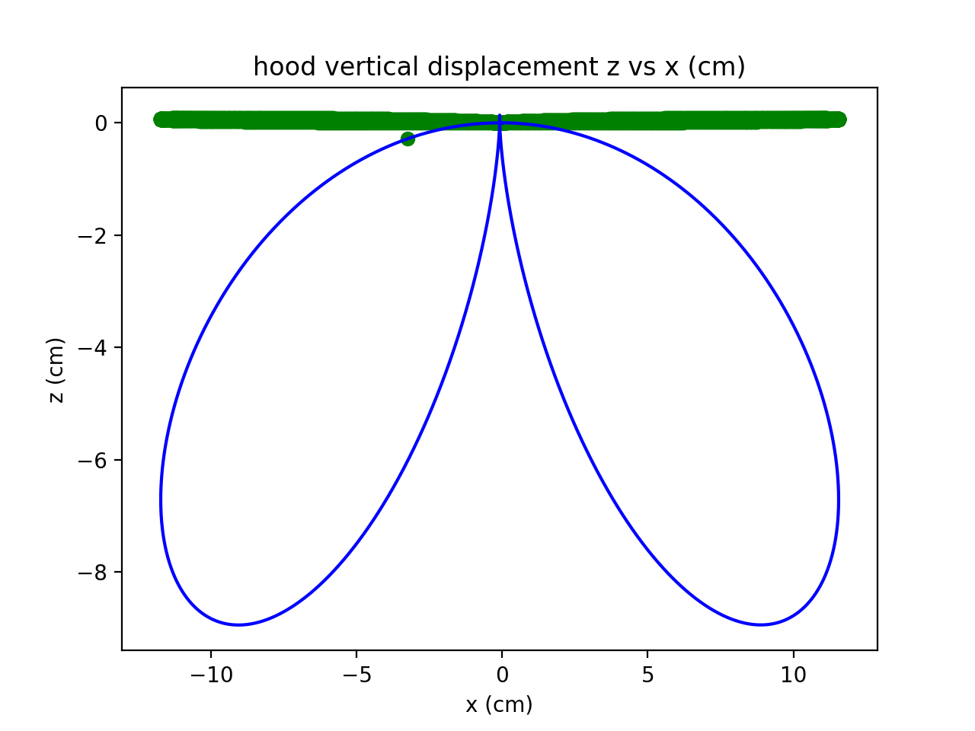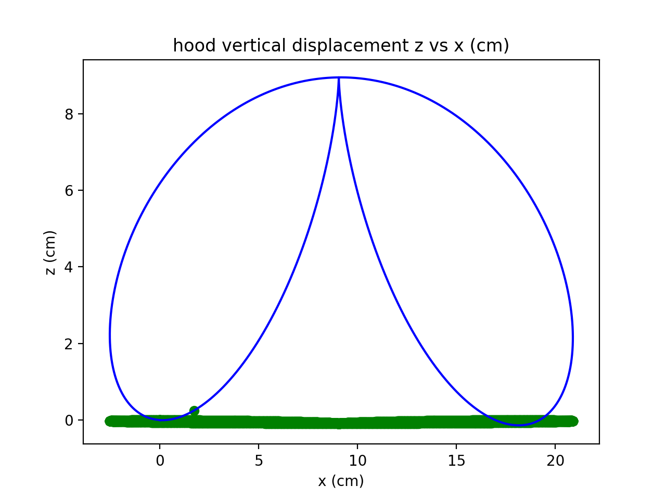

x vs. y

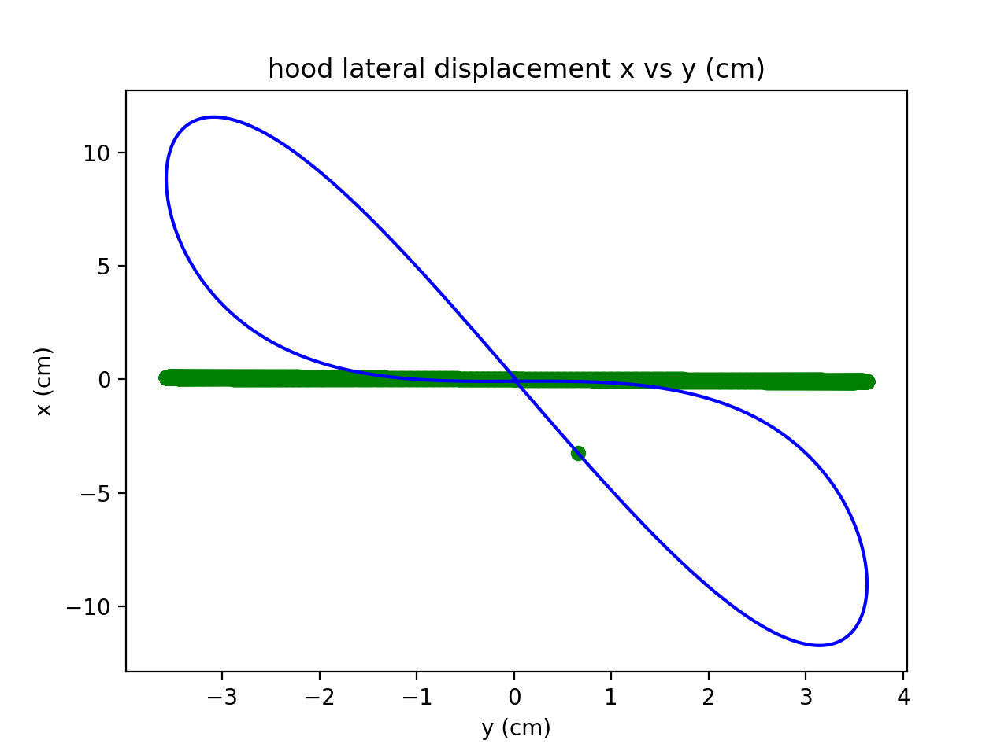 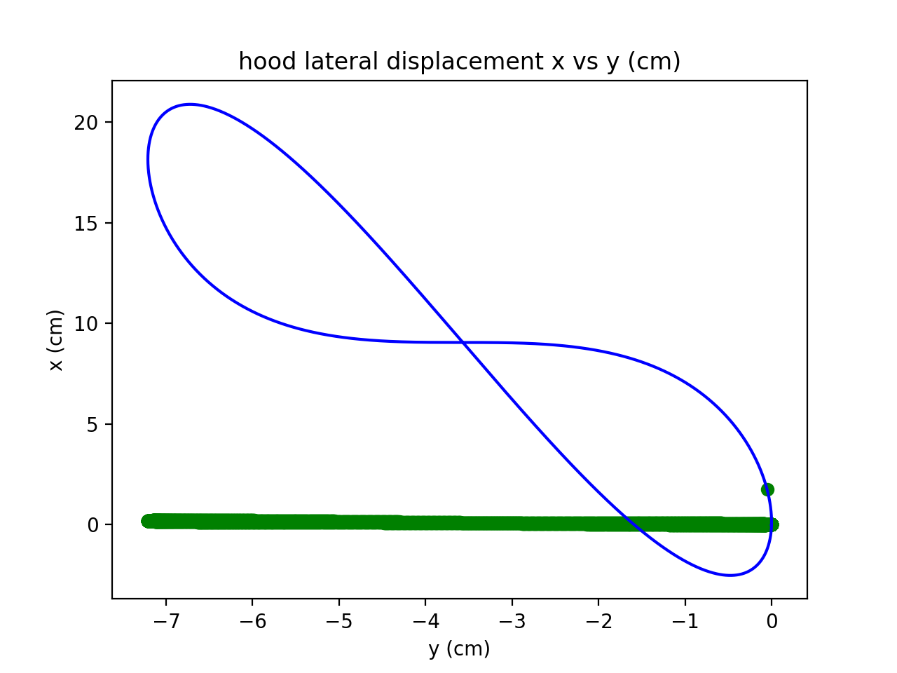

z vs. y

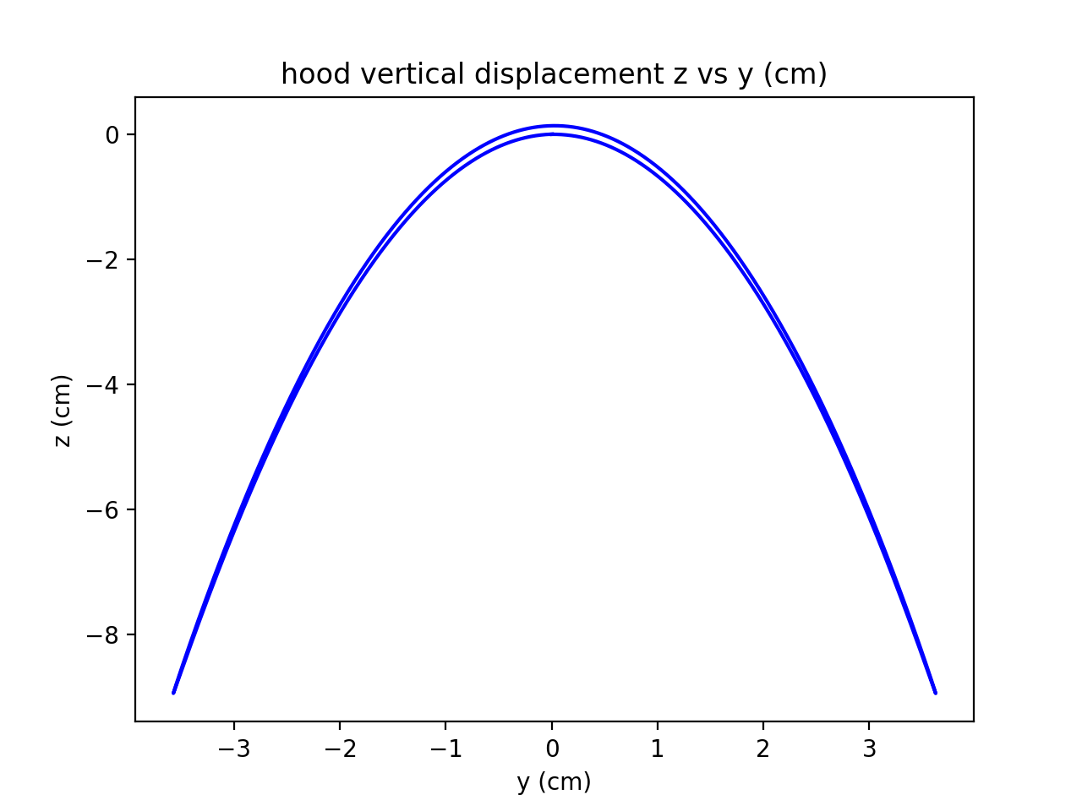 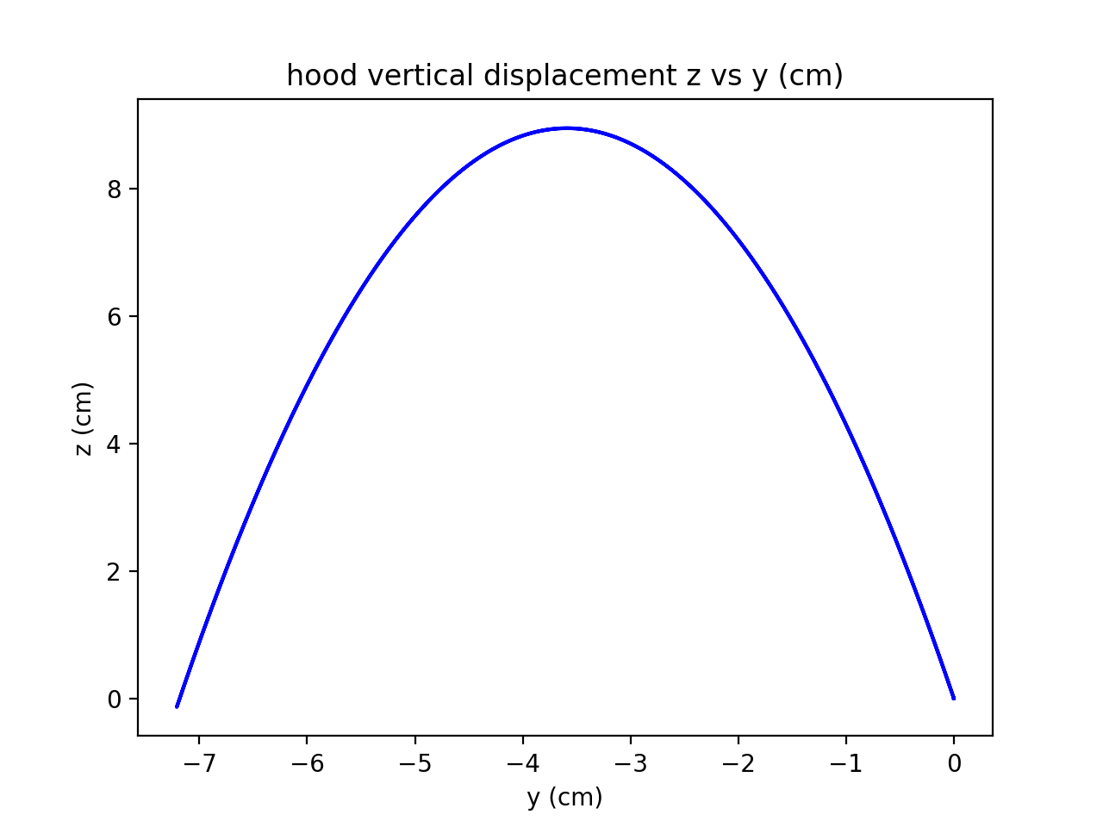

x,y,z vs. time

